Directions: In addition to just simply looking at the infection status in the experimental conditions, you want to evaluate if crabs of different sizes are more likely to become infected. In order to do this, you will measure the crabs like they do in the Shield’s lab.

The upper hard shell of the crab is called the carapace, and scientists look at the Long Carapace Width (LCW) and the Short Carapace Width (SCW). The LCW is the distance from pointy spine to pointy spine whereas the CL (length) is the front to back measurement from point between the eyes to the back of the crab.
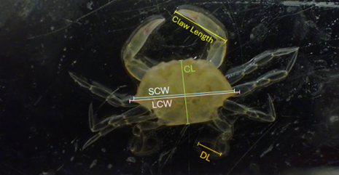

Crab Number | LCW( side to side) | Small or Large  Based on LCW | CL (length)Front to back | Infected or Uninfected
Crab 1 |  |  |  | Infected
Crab 2 |  |  |  | Uninfected
Crab 3 |  |  |  | Infected
Crab 4 |  |  |  | Infected
Crab 5 |  |  |  | Infected
Crab 6 |  |  |  | Infected
Crab 7 |  |  |  | Uninfected
Crab 8 |  |  |  | Uninfected
Crab 9 |  |  |  | Uninfected
Crab 10 |  |  |  | Infected
Crab 11 |  |  |  | infected
Crab 12 |  |  |  | Infected
Crab 13 |  |  |  | Uninfected
Crab 14 |  |  |  | Uninfected
Crab 15 |  |  |  | Infected
Crab 16 |  |  |  | Infected
Crab 17 |  |  |  | Infected
Crab 18 |  |  |  | Uninfected
Crab 19 |  |  |  | Uninfected
Crab 20 |  |  |  | Infected

All of the crabs are juveniles and can be broken into two groups, small 0-15mm and large, 16-30 mm. After you have measured the crabs, designate if they are small or large. Then, fill out the chart below to calculate the prevalence of Hematodinium in the small vs. large crabs.

Calculate the Prevalence for Each Size: Prevalence is the number of infected individuals out of the total population of crabs for each experimental condition. “Small & Large Crab”

Number Infected Small Crabs |  | Number Infected Large Crabs
Total Number Small Crabs |  | Total Number Large Crabs
Fraction for the number of infected |  | Fraction for the number that are infected
Turn the fraction into a percentage |  | Turn the fraction into a percentage

Graphing: Using the percentages you calculated above, create an appropriate graph that can display your data. Be sure to add x and y axis titles and units, in addition to a graph title.



