Name: __________________ Date:____________
Gettin’ Crabby about Parasites

Directions: To determine if Hematodinium parasite is present in a crab, scientists dissect the crab and place the hemolymph (crab blood) onto a microscope slide. They then apply a neutral red stain to the slide. Hematodinium cells absorb the stain and appear red under the microscope. In order to correctly identify the parasite, scientists practice looking through the microscope. It takes time to be able to tell the difference between host (crab) cells and parasite (hematodinum) cells. It is like building any other muscle, it takes time and effort!

Warning! There are several scenarios that can make it especially tricky to determine if the cells on the slide are host or parasite. Some information to consider:
- Some crab cells can take up the neutral red stain. One key feature that scientists use in the lab is the presence of pseudopods, which are arm like structures that help crab cells move. Under the microscope, they appear like stringy clear projections from the cell.

- There are so many hematodinium present on the slide that they “fight” for the stain. In these cases, the hematodinium can appear a light pink color, instead of a deep red. The crab is still considered to be infected.

- Hematodinium cells are more granular (crinkled) than crab cells. Crab cells are circular.

Practice: Look at the following examples and write if it is infected or uninfected.
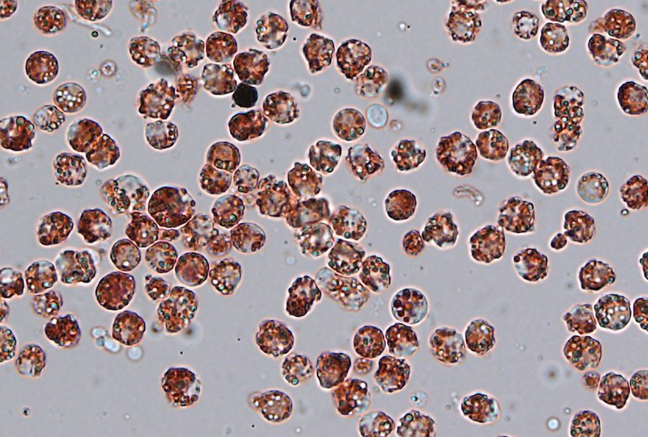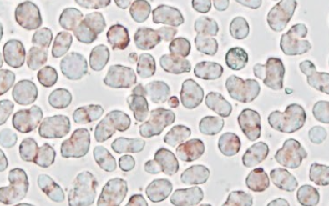

______________________________ ________________________________

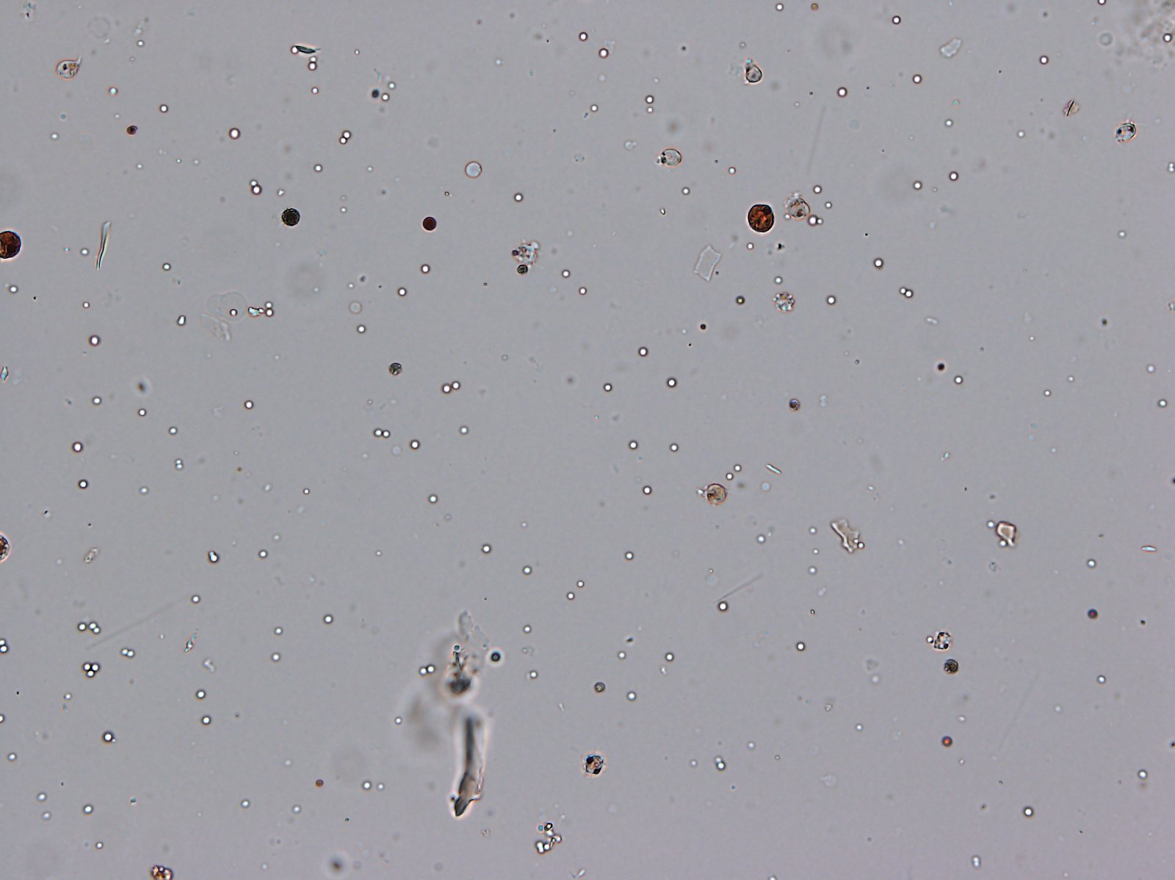

________________________
Data Collection: You need to look at each of the micrographs to determine if the crab was infected with Hematodinium and which of the experimental conditions (control, shell, or oyster) that crab was exposed to. Record your findings in the table.

Crab Number | Infected or Uninfected? | Experimental Condition
1
2
3
4
5
6
7
8
9
10
11
12
13
14
15
16
17
18
19
20

Data Analysis: Based on your data table, count and record the number of crabs that fit into the following categories:

Control Infected: | Shell Infected: | Oyster Infected:
Control Uninfected: | Shell Uninfected: | Oyster Uninfected:
Total Control Crabs: | Total Shell Crabs: | Total Oyster Crabs:

Calculation: Prevalence of Hematodinium infection. Prevalence is the number of infected individuals out of the total population of crabs for each experimental condition.

Number Infected Control Crabs |  | Number Infected Shell Crabs |  | Number Infected Oyster Crabs
Total Number Control Crabs |  | Total Number Shell Crabs |  | Total Number Oyster Crabs
Fraction for the number of infected |  | Fraction for the number that are infected |  | Fraction for the number that are infected
Turn the fraction into a percentage |  | Turn the fraction into a percentage |  | Turn the fraction into a percentage

Graphing: Using the percentages you calculated above, create an appropriate graph that can display your data. Be sure to add x and y axis titles and units, in addition to a graph title.



Analysis Questions:

- What trends do you notice from your graph?
- How does filter feeding impact the amount of hematodinium infection in the blue crabs?

