Directions: In addition to just simply identifying the infection status in the experimental conditions, scientists also measure the size of the crab, to evaluate if crabs of different sizes are more likely to become infected. A common tool that scientists use is called ImageJ, which allows you to set a known distance and then measure an unknown, which in this case is a crab.

ImageJ can be run through a browser at https://ij.imjoy.io/. The ImageJ instructions below have been adapted from Lindsey Smith.

After Accessing ImageJ, Locate the Pictures:
1. Open image in JPEG using either File → Open or by Opening dragging picture into the browser. We are measuring Crabs 1 -20.

Setting the Scale in Images: This is a critical step because you need to set the scale for the computer. Scientists took a picture of each crab on top of a measuring tape which has both inches and centimeters. Science uses metric! So the first step is to identify 1 cm or 10 mm.

1. Select the Straight Line tool. Draw a straight line on the ruler, measuring out 1 cm.
(Hint: If you hold down the “Shift” key as you draw, it makes a straight horizontal line). You want to go from the inside of the start of the cm line to the outside of the cm line, as seen below in yellow.

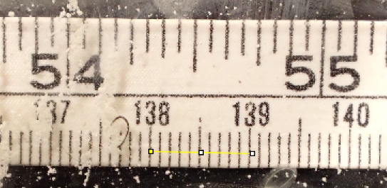

2. After you draw a line, you can adjust it, using the white squares.
3. Select Analyze → Set Scale.
4. In the window, enter “10.0” in Known Distance, and “millimeter” in Unit of Length. Hit “OK.”
5. You need to repeat this process for each crab image that you analyze.

Measuring the Crab:
1. Draw the desired line where you would like to take a measurement.
2. Click Analyze → Measure.
3. Record “Length” in the proper cell of your data table

The upper hard shell of the crab is called the carapace, and scientists look at the Long Carapace Width (LCW) and the Short Carapace Width (SCW). The LCW is the distance from pointy spine to pointy spine whereas the SW is the distance more internally. whereas the Carapace Length CL is the front to back measurement from point between the eyes to the back of the crab. Scientists can also measure claw length and dactyl length, but these measurements are not needed in this study. It takes time to look at the pictures and determine where the correct spot to measure it. Remember, these crabs were alive when scientists took their pictures! Talk with your lab partner to determine the correct place for measurements.

Measure Crabs in Our Study: All of the crabs in this study are juveniles and can be broken into two groups, small 0-15mm and large, 15-30 mm. After you have measured the crabs, designate if they are small or large. Then, calculate the prevalence of Hematodinium in the small vs. large crabs.

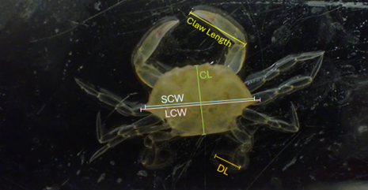

Notes for teachers:
*** One critical component of these measurements in the lab is being able to accurately identify the correct morphology of the crabs. This takes lab staff and students time! These values are ones that we obtained from lab staff when they used ImageJ. It might be interesting for students to compare how accurate their measurements are to the key; however, the most important thing is that students have the correct size designation, small or large. If these designations are incorrect, there will be errors in the resulting prevalence rates.

The only measurement that students need to carry out in order to complete the lesson is the SCW. The others are included here so that students can continue to gain practice with imageJ and get a sense of all the measurements the scientists make. Feel free to remove extra measurements for simplicity.

Crab Number | LCW( side to side) | Small or Large?  (Based on LCW) | SCW | CL (length)  Front to back | Infection infected or Uninfected
Crab 1 | 12.329 | Small | 10.386 | 5.168 | Infected
Crab 2 | 18.277 | Large | 14.974 | 4.435 | Uninfected
Crab 3 | 11.644 | Small | 9.695 | 5.408 | Infected
Crab 4 | 18.925 | Large | 16.061 | 8.554 | Infected
Crab 5 | 12.282 | Small | 10.789 | 6.707 | Infected
Crab 6 | 19.171 | Large | 16.419 | 7.125 | Infected
Crab 7 | 8.259 | Small | 6.572 | 3.746 | Uninfected
Crab 8 | 17.129 | Large | 14.731 | 8.541 | Uninfected
Crab 9 | 10.017 | Small | 7.985 | 8.924 | Uninfected
Crab 10 | 12.394 | Small | 10.246 | 5.659 | Infected
Crab 11 | 18.012 | Large | 15.285 | 8.758 | Infected
Crab 12 | 21.019 | Large | 18.506 | 11.147 | Infected
Crab 13 | 11.893 | Small | 9.976 | 6.321 | Uninfected
Crab 14 | 8.861 | Small | 7.263 | 4.381 | Uninfected
Crab 15 | 19.306 | Large | 16.797 | 5.181 | Infected
Crab 16 | 17.903 | Large | 15.709 | 8.924 | Infected
Crab 17 | 22.242 | Large | 19.176 | 10.837 | Infected
Crab 18 | 12.063 | Small | 10.234 | 5.361 | Uninfected
Crab 19 | 11.397 | small | 9.51 | 5.181 | Uninfected
Crab 20 | 24.198 | Large | 20.24 | 11.857 | Infected

Calculate the Prevalence for Each Size: Prevalence is the number of infected individuals out of the total population of crabs for each experimental condition. “Small & Large Crab”

Number Infected Small Crabs | 4 | Number Infected Large Crabs | 8
Total Number Small Crabs | 10 | Total Number Large Crabs | 10
Fraction for the number of infected | 4/10 | Fraction for the number that are infected | 8/10
Turn the fraction into a percentage | 40% | Turn the fraction into a percentage | 80%

Graphing: Using the percentages you calculated above, create an appropriate graph that can display your data. Be sure to add x and y axis titles and units, in addition to a graph title.

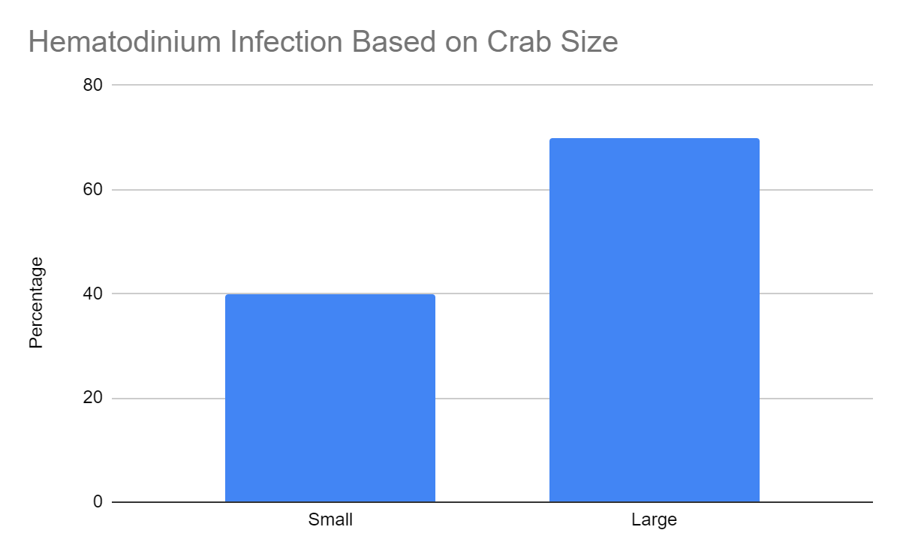

The trend observed here is reflective of what the Shield’s lab has found. This is interesting because all of crabs used were naive, they are from areas where the parasite does not live. Additionally, all crabs were deployed for the same amount of time, 10 days in the Eastern Shore, where Hematodinium parasite is hyper-endemic.This means that the larger crabs aren’t becoming infected more simply because they are larger/older, but rather, it seems that smaller juveniles are protected. Shield’s lab think that there is some sort of surface area/volume ratio factor in the gills, which is where the parasite likely enters the crabs.

