Name: __________________ Date:____________
Gettin’ Crabby about Parasites

Directions: To determine if Hematodinium parasite is present in a crab, scientists dissect the crab and place the hemolymph (crab blood) onto a microscope slide. They then apply a neutral red stain to the slide. Hematodinium cells absorb the stain and appear red under the microscope. In order to correctly identify the parasite, scientists practice looking through the microscope. It takes time to be able to tell the difference between host (crab) cells and parasite (hematodinum) cells. It is like building any other muscle, it takes time and effort!

Warning! There are several scenarios that can make it especially tricky to determine if the cells on the slide are host or parasite. Some information to consider:
- Some crab cells can take up the neutral red stain. One key feature that scientists use in the lab is the presence of pseudopods, which are arm like structures that help crab cells move. Under the microscope, they appear like stringy clear projections from the cell.

- There are so many hematodinium present on the slide that they “fight” for the stain. In these cases, the hematodinium can appear a light pink color, instead of a deep red. The crab is still considered to be infected.

- Hematodinium cells are more granular (crinkled) than crab cells. Crab cells are circular.

Practice: Look at the following examples and write if it is infected or uninfected.
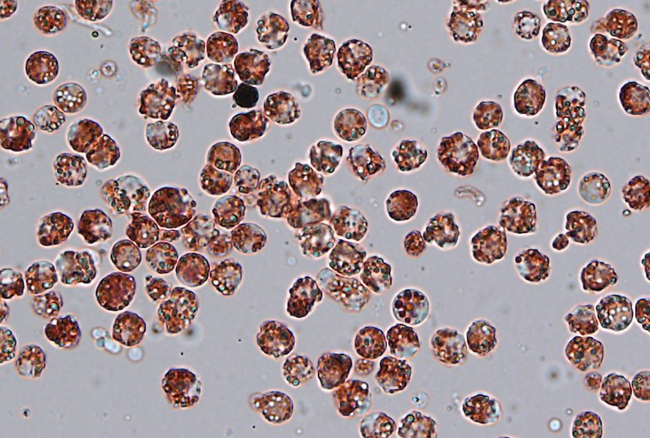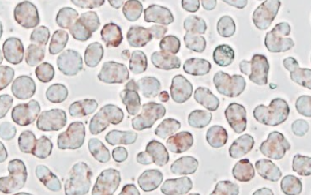

______infected_________ infected, stain not picked up by parasites, too many of them.

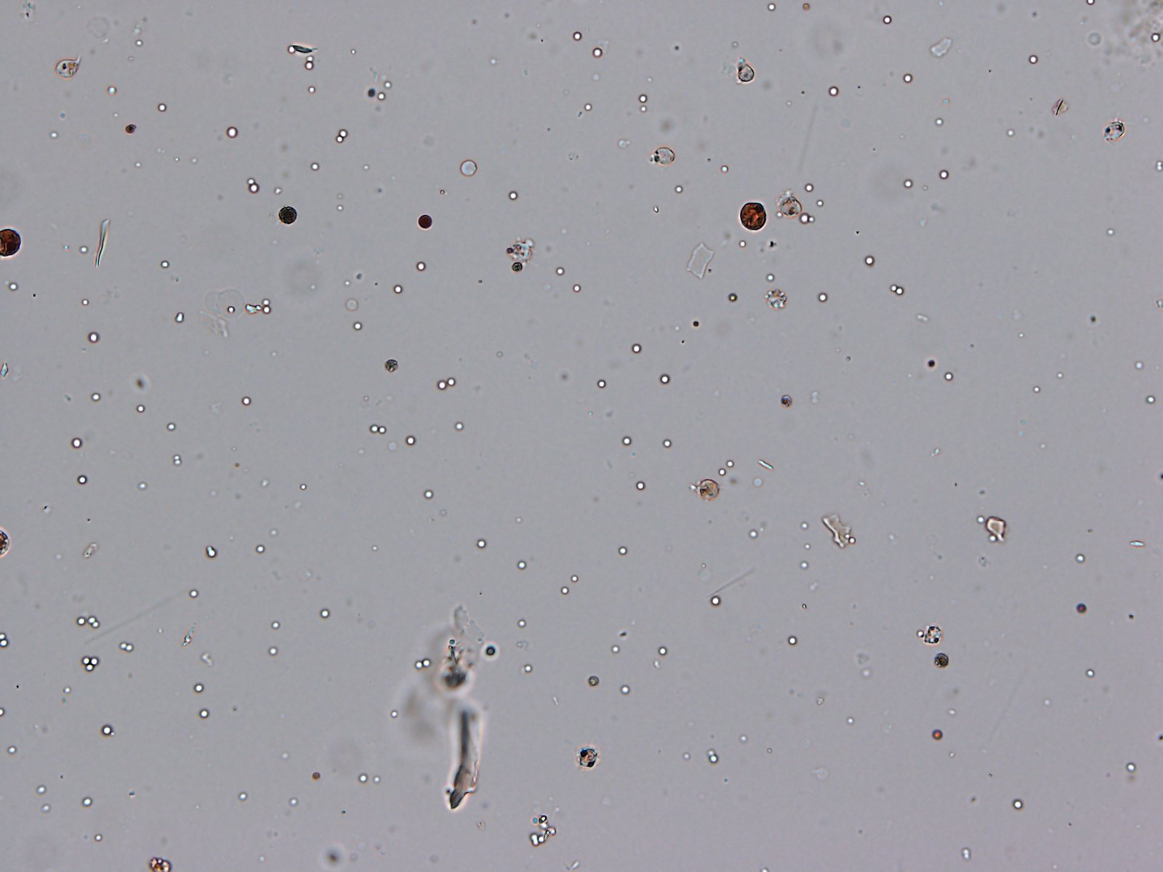

______uninfected_________

Data Collection: You need to look at each of the micrographs to determine if the crab was infected with Hematodinium and which of the experimental conditions (control, shell, or oyster) that crab was exposed to. Record your findings in the table.
Crab Number | Experimental Condition | Infected or Uninfected? | Notes
1 | control | infected
2 | oyster | uninfected
3 | control | infected
4 | Shell | Uninfected | The red cells are round and are likely host cells. Staining pattern is more consistent w host cell than parasite
5 | control | infected
6 | control | infected
7 | shell | uninfected
8 | control | uninfected
9 | oyster | uninfected
10 | oyster | infected
11 | shell | infected | Granularity is really clear in this image. On bottom right,, you can see the pseudopods of host (crab) cells.
12 | control | infected
13 | oyster | uninfected | Pseudopods visible here, so even though some red stain was taken up, it was taken up by crab cells. Hematodinium do not have the pseudopods.
14 | Control | uninfected | This is an example where cellular debris look red, but they are not hematodinium cells.
15 | control | infected
16 | shell | infected
17 | control | infected
18 | oyster | uninfected
19 | shell | uninfected | These are either host cells or other organisms, do not have correct shape for hematodinium
20 | control | infected

Data Analysis: Based on your data table, count and record the number of crabs that fit into the following categories:

Control Infected:  8 | Shell Infected:  2 | Oyster Infected:  1
Control Uninfected:  2 | Shell Uninfected:  3 | Oyster Uninfected:  4
Total Control Crabs:  10 | Total Shell Crabs:  5 | Total Oyster Crabs:  5
Total Crab Pictures = |  | 20

Calculation: Prevalence of Hematodinium infection. Prevalence is the number of infected individuals out of the total population of crabs for each experimental condition.

Number Control Infected Crabs | 8 | Number Shell Infected Crabs | 2 | Number Oyster Infected Crabs | 1
Total Number Control Crabs | 10 | Total Number Shell Crabs | 5 | Total Number Oyster Crabs | 5
Fraction for the number of infected | 8/10 | Fraction for the number that are infected | 2/5 | Fraction for the number that are infected | 1/5
Turn the fraction into a percentage | 80% | Turn the fraction into a percentage | 40% | Turn the fraction into a percentage | 20%

Graphing: Using the percentages you calculated above, create an appropriate graph that can display your data. Be sure to add x and y axis titles and units, in addition to a graph title.

Graphs can vary slightly, but students should use a bar graph because this is categorical data.

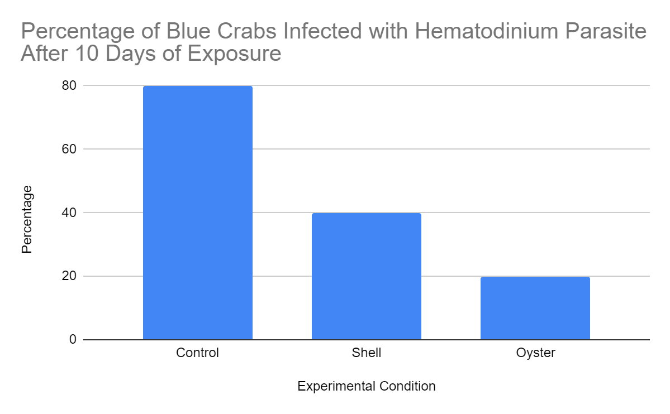

Analysis Questions:
What trends do you notice from your graph?

Control crabs are 80% likely to become infected whereas the oysters are 40% likely. We see that the oyster condition reduces the infection the most. The shell condition reduced infection rate, but not as much as the oysters did. In the larger datasets, when the Shield’s lab ran the statistics, there isn’t a statistical difference between the control and shell conditions, but there is a statistical difference between those two and the oyster condition. In short, filter feeders reduce the amount of hematodinium infection.

How does filter feeding impact the amount of hematodinium infection in the blue crabs?

See above. The oysters remove the parasite from the water column, which reduces the likelihood that they infect the crabs.

